Summary

An attempted CCTV survey was carried out on Leacroft Borehole (site ref 640.1) on the 27th June 2019.

Unfortunately, due to the diameter of the borehole the CCTV survey was unable to be carried out, as well as water sampling for onsite and laboratory testing.

However, a conductivity and temperature profile and a Calliper survey were undertaken.

The conductivity and Calliper survey were both terminated at 149.29mBGL. The original depth of the borehole was 165m, it is assumed there was a blockage at 149.29mBGL, however without CCTV footage it is not possible to confirm.

The calliper survey shows the internal diameter to be approximately 50mm throughout.

Immediately prior to the survey, water level was manually dipped at 75.3 mbgl. This water level was confirmed as 75.21 mbgl by interpretation of the temperature and conductivity logs.

The results of the surveys undertaken are presented in Figure 2, Figure 3 and Figure 4.

Water Level comparison to routinely collected data

Water level readings are undertaken by STS at Leacroft borehole (Figure 1) every three months.

Over the last two years, water level readings have varied some 30m, with an erratic pattern, as show in Figure 1 and Table 1. The results of the conductivity and temperature survey suggest water level is approximately 75mBGL, approximately 82mAOD. Therefore over 50% of the readings from the last two years are considered likely to be incorrect and that there is a discrepancy in manual water level readings.

It is recommended that a data logger be installed in this borehole to allow for accurate and frequent water level recordings to be undertaken.

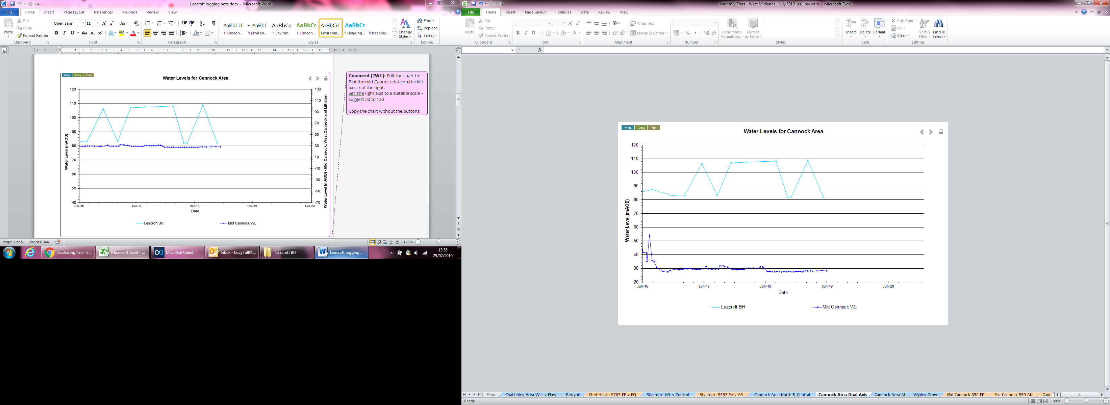

Figure Water Levels at Leacroft BH

Table 1 Summary of water levels for Leacroft Borehole since 2017

|  |  |  |
| --- | --- | --- |
| Date | Water Level (mAOD) | Verified by survey? |
| 10/02/2017 | 82.82 | Yes |
| 25/05/2017 | 106.15 | No |
| 25/08/2017 | 83.03 | Yes |
| 14/11/2017 | 106.91 | No |
| 15/02/2018 | 107.41 | No |
| 24/05/2018 | 107.80 | No |
| 10/08/2018 | 108.16 | No |
| 18/10/2018 | 81.94 | Yes |
| 09/11/2018 | 81.97 | Yes |
| 15/02/2019 | 108.73 | No |
| 17/05/2019 | 81.91 | Yes |

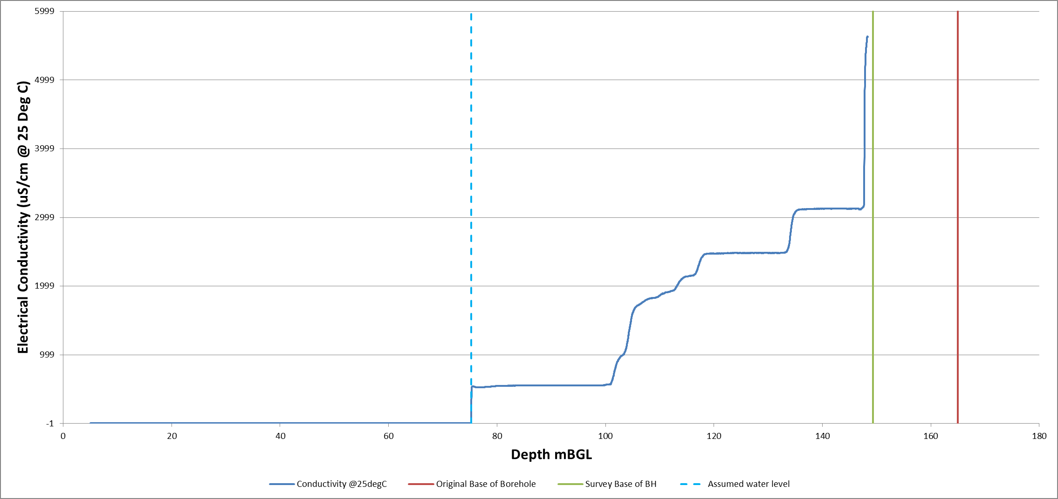

Figure 2 Electrical Conductivity Vs Depth

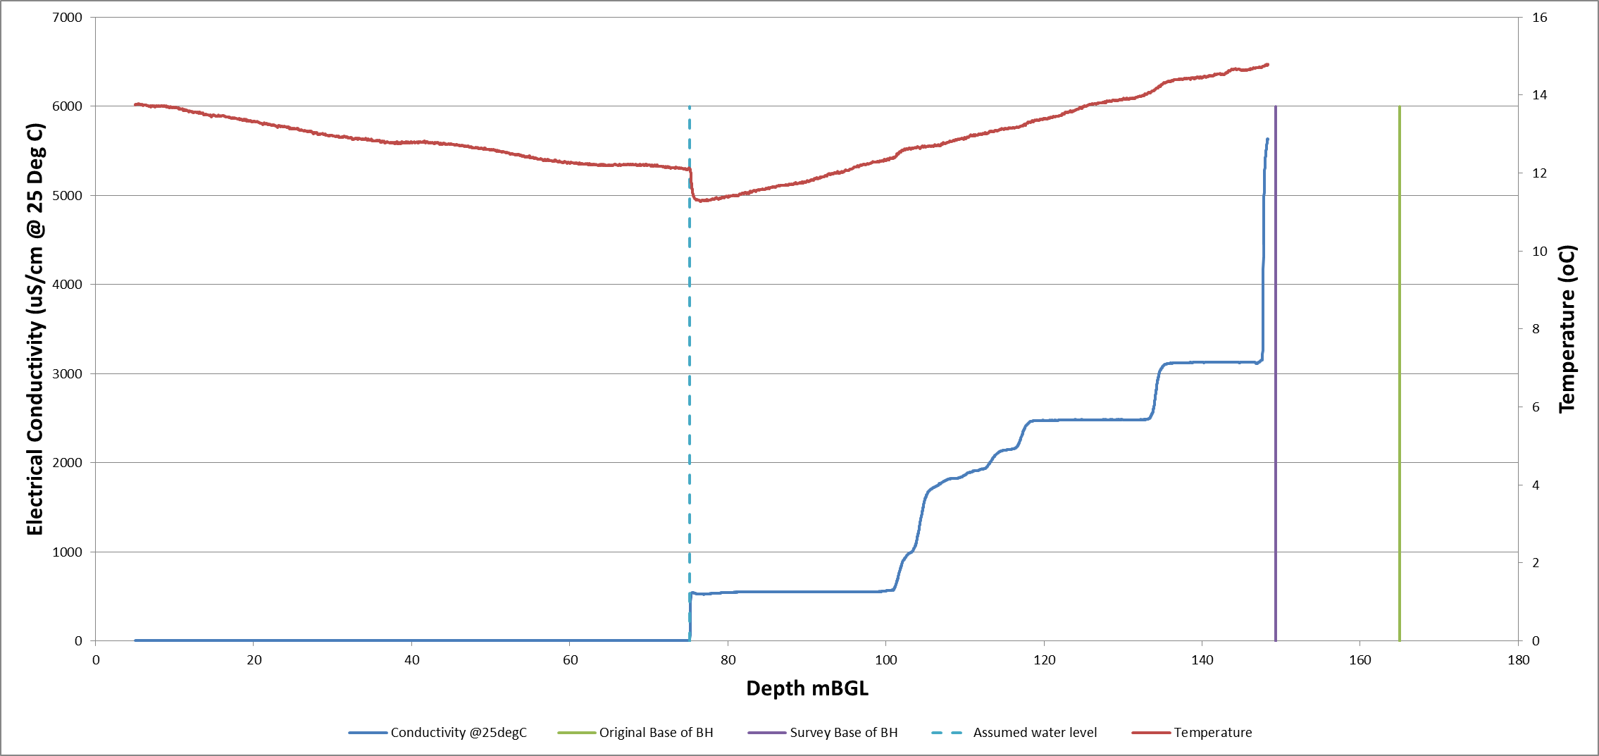

Figure 3 Electrical Conductivity Vs Temperature

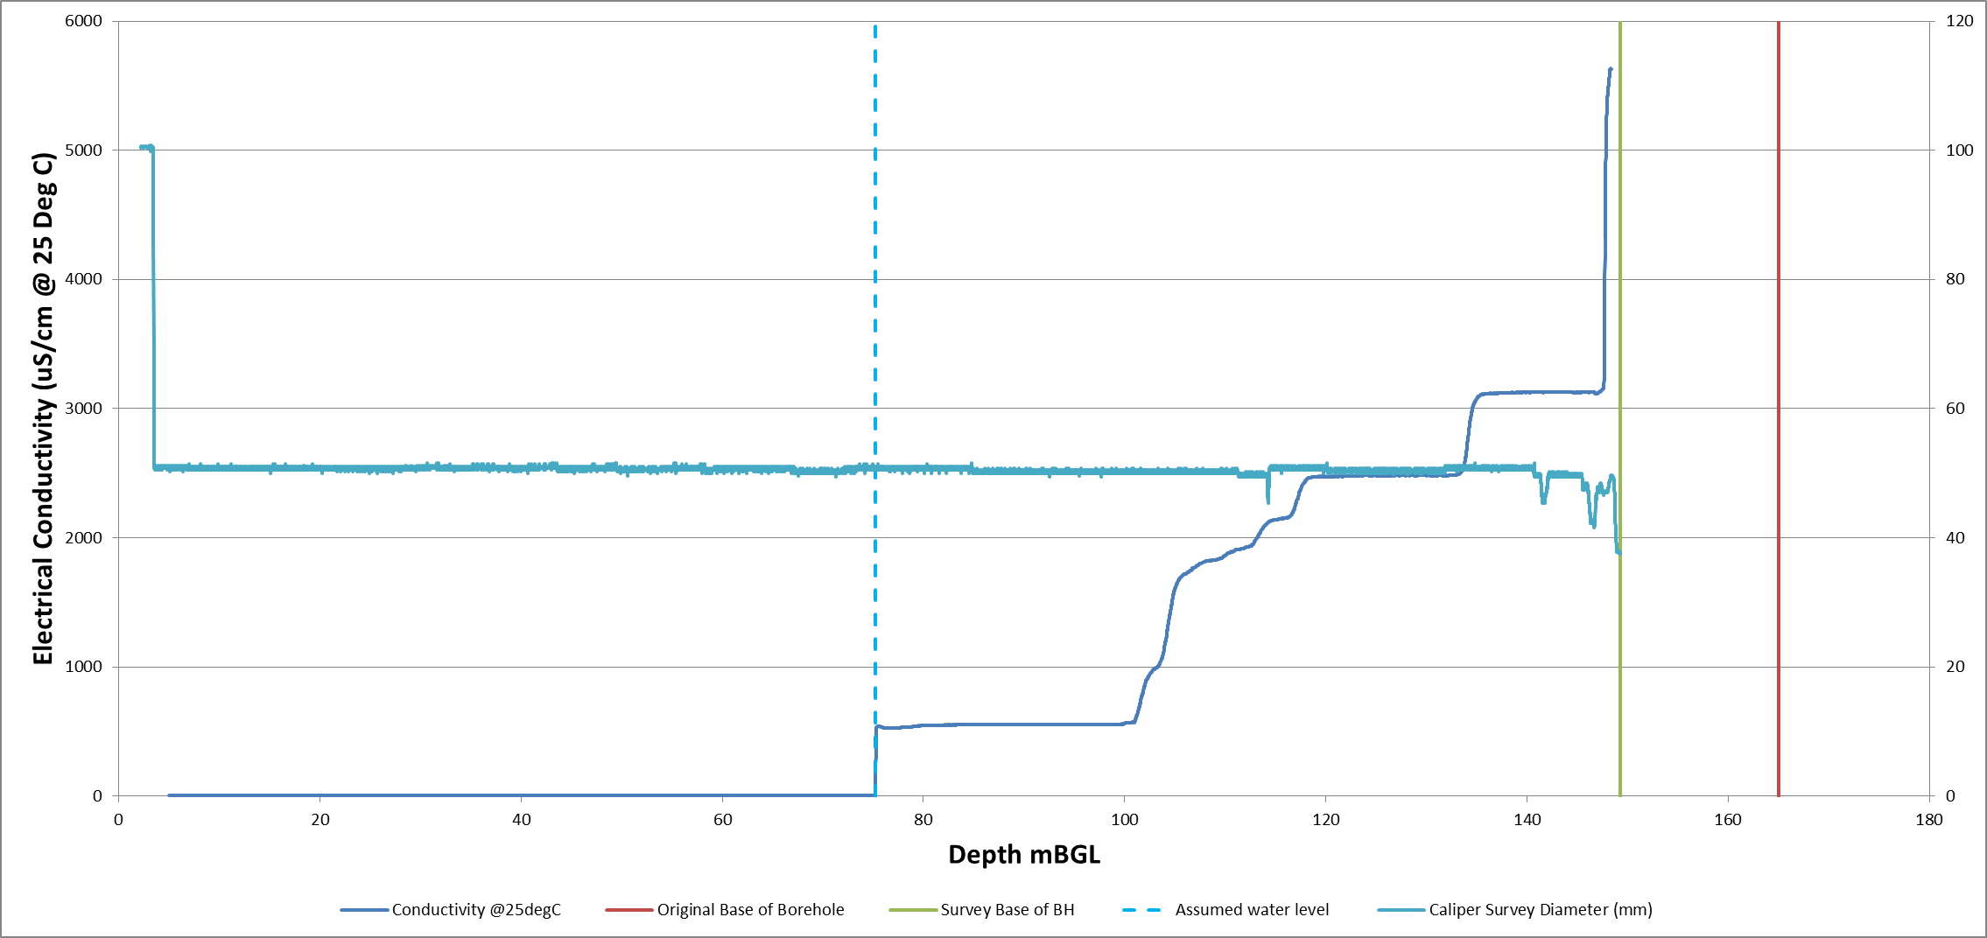

Figure 4 Electrical Conductivity Vs Calliper Survey Diameter